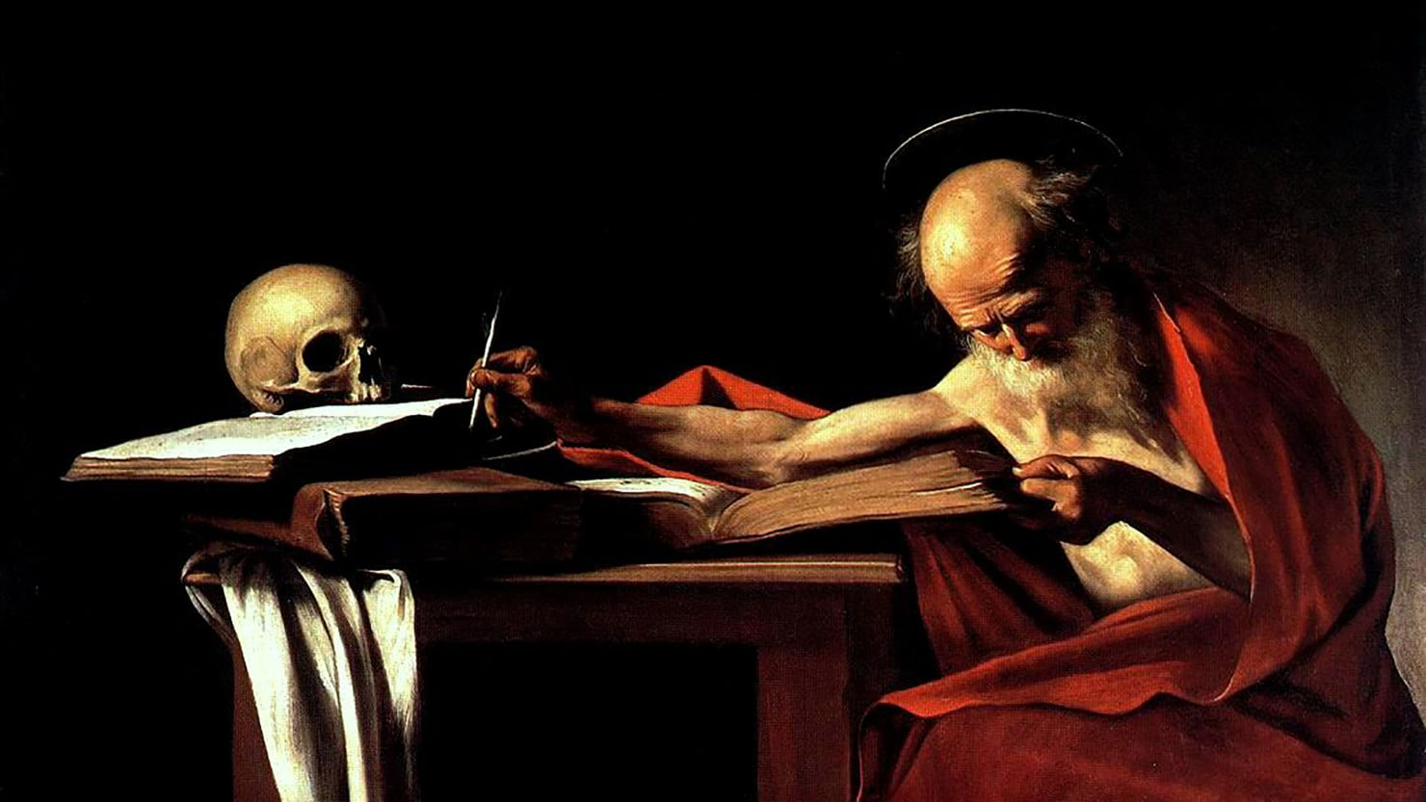

http://www.reddit.com/submit?title=Interpreting the Bible Just Got More Complicated&url=http%3A%2F%2Fwww.thedailybeast.com%2Finterpreting-the-bible-just-got-more-complicated%3Fvia%3Ddesktop%26source%3DReddit

UH OH

Interpreting the Bible Just Got More Complicated

The English translation of the recently discovered oldest Latin version of the Gospels may be problematic for those who want to read the Bible as a literal history.
Candida Moss

09.03.17 12:00 AM ET
In October 2012, Dr. Lukas Dorfbauer, a researcher at the University of Salzburg, was examining the manuscripts of the Cologne Cathedral Library. He was looking at an anonymous manuscript and realized that this ancient manuscript contained the earliest Latin commentary on the Gospels. Dorfbauer was not the first scholar to examine the manuscript, but he was the first to realize its significance: here, as part of the 100-page fourth century c.e. commentary, was the earliest Latin translation of the Gospels. And now, it’s available in English, and the implications are enormous.
The author of the commentary was Fortunatianus of Aquileia, a fourth-century North African who later became a northern Italian bishop. Scholars had known about the commentary from references to it in other ancient works, but until Dorfbauer identified the Cologne manuscript it had been lost for more than 1,500 years.
Ironically, when scholars had looked at this turn-of-the-ninth century manuscript in the past they had been much more interested in a forged letter “on Pride and Folly” that claimed to be from the Jewish High Priest Annas to the famous Roman Stoic philosopher Seneca. To be sure, forged letters between Seneca and Christian religious figures are fascinating (there’s a set of letters between the Apostle Paul and Seneca, as well), but they are of little consequence next to the earliest extant Latin translation of the Bible.
The rediscovery of Fortunatianus’ commentary is itself of enormous significance. He was so highly regarded by his successors that a number of ninth-century theologians had looked for his commentary and come up empty-handed. What makes this particular discovery truly astonishing is that the text of the Gospels that it uses is different from the next-oldest known Latin translation of the Bible.
Up until now the oldest complete Latin version of the Gospels was the Vulgate, a late-fourth-century translation attributed to the priest and theologian Jerome. Jerome, incidentally, was a great admirer of Bishop Fortunatianus, describing his commentary as “a pearl without price.” Pope Damasus I commissioned Jerome to update the “Old Latin” (Vetus Latina) version of the Gospels used by the Roman Church. Jerome went one better, compiling a translation of the entire Bible. The influence of the Vulgate is enormous; over a thousand years later, at the Council of Trent, the Roman Catholic Church would affirm that it was the “authentic” Bible.
But now we have more evidence of something older. The English translation of the text was prepared by Dr. Hugh Houghton, Deputy Director of the University of Birmingham’s Institute for Institute for Textual Scholarship and Electronic Editing (ITSEE), and is available online for free from De Gruyter press.
What’s most revealing about the commentary is the manner in which its author interprets his source text. Rather than treating the Gospels as literal history, Fortunatianus view these stories them as a series of allegories. For example, when Jesus enters a village, Fortunatianus might see the village as a cipher for the church. Other “figures” of the Church include boats, sheep, and hens. Other instances of this kind of reading involve numbers: the number twelve is always a reference to the twelve disciples; the number five is a symbol of the five books of the Pentateuch, or Jewish law; and the number ninety-nine (an imperfect version of 100) is a symbol of evil and the Jews (I take no responsibility for his anti-Judaism).
Houghton said, “For people teaching the Bible in the fourth century, it's not the literal meaning which is important, it's how it's read allegorically.” It’s not that Fortunatianus thinks that the Bible cannot be read literally, it’s just that he is much more interested in its symbolic meaning. While he sometimes uses the verbs “to figure” or “prefigure” to explain his interpretation, he mostly describes the passages as “showing” or “indicating” a particular allegorical truth.
What’s especially striking about this new discovery is that Fortunatianus is commenting on the content of the Gospels, the central component of the Christian message. This seems strange to modern readers because so much modern religious Biblical interpretation, especially among conservative Christians, assumes that Bible should be read literally. Houghton notes that literal interpretation did not become de rigueur until the mid-15th century, when the invention of the printing press brought precise uniformity and conformity to the Biblical text. Prior to this point no two manuscripts of the Bible were identical to one another, and literal reading of the text was just one (and not even necessarily the most important) interpretive method.
Of course, allegorical readings of the Bible pre-date Fortunatianus. One of the most celebrated ancient interpreters of scripture, the third-century theologian Origen of Alexandria (who is a likely source for Fortunatianus), argued that the Bible could be interpreted literally (what he calls the “letter”) and spiritually (allegorical interpretation). He actually distinguished three kinds of interpretation that he mapped on to the parts of the human body: “the flesh,” “the soul,” and “the spirit.” Origen’s three senses of scripture have been profoundly influential and led him to offer some startlingly modern interpretations.
For example, when writing about the (in modern contexts) highly controversial Creation stories of Genesis 1-3, Origen says this: “For who that has understanding will suppose that the first day, and second and third day, and the evening and the morning existed without a sun, and moon, and stars? And that the first day was, as it were, also without a sky? . . . . And if God is said to walk in paradise in the evening, and Adam is to hide himself under a tree, I do not suppose that anyone doubts that these things figuratively indicate certain mysteries, the history having taken place in appearance and not literally.” In other words, Origen doesn’t think that the Genesis stories are literally true. He doesn’t write this as a response to scientific discovery, but he also does not think that the stories are bankrupted as a result. Instead, he thinks, like many others, that these stories are meant to be interpreted allegorically. Allegory isn’t a response to science, it’s an authentic and historically grounded way of reading and writing texts.
For most people invested in the religious authority of the Bible none of this will be too shocking. After all, as Houghton himself points out, reading the Bible as allegory can actually solve some of the difficulties that readers encounter when they read the New Testament: “There's been an assumption that it's a literal record of truth – a lot of the early scholars got very worried about inconsistencies between Matthew and Luke.” What writers like Fortunatinus and Origen show is not just that you don’t have to read the Bible literally all the time, but that for most of the Christian Era nobody thought that you should.

